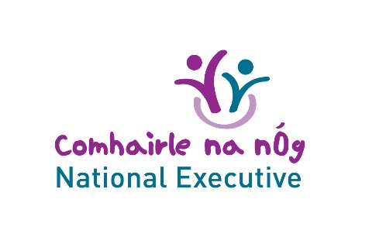
National Executive presentation and Q&A with Dept of Transport
14th May 2020

Attendees:
Racheal Diyaolu, Carlow, Roisin O’Rourke, Cavan; Laoise Galvin-Byrne, Clare; Carl Dwyer-Murphy, Cork County; Ayushi Mahajan, Cork City; Beth Doherty, Sineaid Whelan, DLR; Dublin City; Jake Bushe, South Dublin; Liam Hannigan, Donegal; Jack Leahy, Fingal; Molly Whelehan, Galway County; Kate Hogan, Laois; Yvonne Farrell, Kildare; John Heslin, Leitrim; Aoife Ryan, Limerick; Cáit Mahon, Longford; Rebecca Staunton, Mayo; Daniela Lupo, Meath; Ronan Garrivan, Monaghan; Aaron Masterson Weir, Offaly; Molly Beckett, Roscommon; Jo Wooten, Tipperary; Abby Vaianella, Waterford; Christopher Lynn, Westmeath, Quinton Kelly, Wexford and Imogen Horton, Wicklow – in total

Decision: to not hold another National Executive meeting until after 29th May to allow for members to finish school exams

Guest speakers:
- Laura Behan, Climate Change Unit, Department of Transport, Tourism and Sport
- Carol O’Reilly, Sustainable Mobility (Investment & Policy) Division, Department of Transport, Tourism and Sport
- Sadbh Quinn, Sustainable Mobility (Investment & Policy) Division, Department of Transport, Tourism and Sport

Two presentations on the following areas:
- Decarbonising Transport Overview - targets, where transport emissions arise, some overview on why and how people travel, effective decarbonising measures in transport
- Active Travel and Investment – investment and infrastructure plans, active travel statistics, active travel policy development and measures
Presentations can be found on the website – link here

Questions from members of the Executive re: Laura’s presentation:
Q: The mining of cobalt for use in electric car batteries is a serious human rights issue. What can we in Ireland do to ensure that car components are sustainably sourced?
A: Difficulty is that there are no manufacturers in Ireland so we are reliant on overseas manufacturers. It can be difficult to control from here. However the onus is on us to ensure that we put pressure on car manufacturers and only buy from those who can guarantee sustainable materials that are ethically sourced.

Q: Lower-income families are disproportionately affected by the carbon-tax. The grants given for the purchase of electric cars cannot breach the income gap between rich and poor which means that lower-income families cannot afford to buy sustainable cars. Could the government look at a subsidised grant system for hybrid-cars?
A: The Government cannot subsidise cars that are petrol or diesel hybrid cars. But they had to start somewhere to get electric cars on the market. 110,000 cars are sold every year in Ireland. The rest are second-hand. Those new cars will come back into the system in a few years and can be sold for a more affordable price as second-hand vehicles.
The grant is essentially equalising prices for those in a position to buy a new car, making it the same price as a petrol or diesel. Further down the line they will become the more affordable second-hand cars. It’s not an ideal situation but it’s a starting point for now.

Questions from members of the Executive re: Sadbh’s presentation:
Q: Moving away from the use of cars in rural areas is not an easy option when there are no alternative public transport options. What is being done here?
A: Services which operate as registered services, as well as on-demand services to serve the harder to reach areas. Use of different methods for different areas. Local Link has been a good example.

Q: What way have you engaged with communities?
A: Stakeholder engagement events. Public consultations. Behavioural change programmes – looking at changing attitudes to cycling / walking from a young age. Research shows that this one of the most effective ways of ensuring the engraining of active travel as an option is to start from the early years.

NEXT STEPS:
- Next meeting to be held after exams. Date TBC
- There will not be a guest speaker. Instead we will review our progress to date as a group and look at where we are going with our topic, ensuring we are staying true to the findings of the Dáil na nÓg workshop report.
- Based on recent evaluation circulated to the group, Renagh will come up with a survey for circulation to the group in relation to more suitable meeting times, in addition to preferences on what areas we progress as a topic. To be circulated on week commencing 18th May. Responses will be reviewed in advance of meeting.

